Major Research Project Part-II (ICT-652) on
“Performance Analysis of Federated Learning under Non-IID Financial Tabular Data Distributions”

Submitted in partial fulfilment of the requirement for the award of the degree of
MASTER OF TECHNOLOGY
in
COMPUTER SCIENCE AND ENGINEERING (2024-2026)
Under the guidance of: Submitted by:
Dr. M. Bala Krishna Priyanshu Bhardwaj Professor 02716404824
USICT M.Tech CSE



UNIVERSITY SCHOOL OF INFORMATION, COMMUNICATION AND TECHNOLOGY (USICT)

GURU GOBIND SINGH INDRAPRASTHA UNIVERSITY, NEW DELHI-110078
May 2026

CERTIFICATE

The Dissertation (Major Research Project Part-II) (ICT-652) titled “Performance Analysis of Federated Learning under Non-IID Financial Tabular Data Distributions” submitted to the University School of Information, Communication and Technology, Guru Gobind Singh Indraprastha University, Delhi by Priyanshu Bhardwaj, Enrollment No. 02716404824 is a part of M.Tech (CSE) IVth Semester.

Professor Dr. M Bala Krishna
USICT, GGSIPU
New Delhi Date:

DECLARATION OF THE STUDENT

This is to certify that I Priyanshu Bhardwaj, roll no. 02716404824 of M.Tech (CSE) IVth Sem from USICT, GGSIPU, New Delhi takes full responsibility for the content of this ICT-652 Major Research Project Part- II titled as “Performance Analysis of Federated Learning under Non-IID Financial Tabular Data Distributions” source code and relevant modules accountable for the work done by me.

I hereby declare that the synopsis/ progress report/ ICT-652 Major Research Project Part II source code and the relevant modules are not plagiarized from any source directly or indirectly. If any plagiarism found I shall be responsible for the same.

I hereby further declare and certifythat:

- The work contained in the synopsis, progress report is original and has been done by me.
- The work has not been submitted to any other Institution for any other degree/diploma/certificate in this university/other University or any organization, etc. of India or abroad.
- I have followed the standard guidelines in writing the report.
- I hereby declare that I will not upload or publish this Dissertation Report ICT-652 in any of the online or offline forums and International or National conferences/ journals/ events/ forums etc.
- Whenever I have used the materials (data, theoretical analysis, and text) from other sources, I have given due credit to them in the text of the report and giving their details in the references.
- I hereby declare that the contents of this project report is not taken from any Al tools such as ChatGPT, Open Al, Chatbot, Deepseek, etc,

Date: Signature:
New Delhi Name: Priyanshu Bhardwaj
Roll No: 02716404824
M.Tech CSE, IVth Sem Phone No:7463920290
handsomehiwatari@gmail.com

ABSTRACT

The rapid expansion of digital financial systems has generated large volumes of sensitive transactional data, creating new opportunities for machine learning applications such as credit risk prediction and fraud detection. However, conventional centralized learning approaches require data sharing across institutions, which raises concerns regarding privacy, confidentiality, and regulatory compliance. Federated Learning (FL) has emerged as a privacy-preserving distributed learning paradigm that enables multiple participants to collaboratively train a global model without exchanging raw data. This study investigates the performance of federated learning for credit default prediction under different data distribution scenarios using the UCI Credit Card Default dataset. A centralized logistic regression model was first developed as a baseline, followed by federated experiments using the Federated Averaging (FedAvg) and Federated Proximal (FedProx) algorithms. The study evaluates model performance under Independent and Identically Distributed (IID) conditions, label skew, and quantity skew using accuracy, precision, recall, F1-score, and log loss metrics. Experimental results show that federated learning under IID conditions achieves performance comparable to centralized training, with an accuracy of 80.80%. However, significant performance degradation is observed under heterogeneous label skew scenarios, where accuracy decreases to 66.93% under 70% skew and 64.38% under 90% skew. In contrast, quantity skew has minimal impact on overall performance. Comparative analysis further indicates that FedProx provides improved convergence stability and slightly better accuracy than FedAvg under severe Non-IID conditions. The findings demonstrate that statistical heterogeneity, particularly label skew, remains a major challenge in federated optimization. This work highlights the trade-off between privacy-preserving decentralized learning and predictive performance, while emphasizing the need for more robust federated optimization strategies for real-world financial systems.

TABLE OF CONTENTS

Title | Page No.
CERTIFICATE | i
DECLARATION | ii.
ABSTRACT | iii.
TABLE OF CONTENTS | iv.
LIST OF FIGURES | vi.
LIST OF TABLES | vii.
1. INTRODUCTION | 1
1.1 Background and Context | 1
1.2 Problem Statement | 1
1.3 Research Objectives | 2
1.4 Scope and Contributions | 2
2. LITERATURE REVIEW | 4
2.1 Overview of Federated Learning | 4
2.2 Federated Averaging and Optimization Methods | 4
2.3 Non-IID Data Challenges in FL | 5
2.4 Federated Learning in Financial Risk Prediction | 6
2.4.1 Comparative Summary of Related Work | 7
2.5 Research Gaps | 10
3. METHODOLOGY AND EXPERIMENTAL DESIGN | 12
3.1 Problem Formulation | 12
3.2 Federated Learning Architecture | 13
3.3 Dataset and Preprocessing | 15
3.4 Client Data Partitioning Strategies | 16
3.5 Model and Training Configuration | 17
3.6 Evaluation Metrics | 17
4. RESULTS AND DISCUSSION | 19
4.1 Centralized Baseline Performance | 19
4.2 Federated Learning under IID Distribution | 20
4.3 Impact of Label Skew on Federated Learning | 22

4.3.1 Moderate Label Skew (70%) | 23
4.3.2 Severe Label Skew (90%) | 24
4.4 Impact of Quantity Skew on Federated Learning | 26
4.5 Comparative Analysis (FedAvg vs FedProx) | 29
4.5.1 Comparison under Moderate Label Skew (70%) | 29
4.5.2 Comparison under Severe Label Skew (90%) | 31
4.5.3 Convergence Behavior Analysis | 33
4.5.4 Overall Discussion and Insights | 33
4.6 Explainability Considerations for Federated Credit Risk Models | 34
4.7 Practical Implications for Financial Institutions | 35
4.8 Summary of Experimental Findings | 37
5. CONCLUSION AND FUTURE WORK | 38
5.1 Summary of Findings | 38
5.2 Limitations | 39
5.3 Future Directions | 40
REFERENCES | 42

LIST OF FIGURES

Figure | Pg No.
3.1 FL architecture using the FedAvg aggregation mechanism | 13
3.2 Experimental pipeline for federated learning-based credit default prediction | 15
4.1 Confusion Matrix for the Centralized Logistic Regression model | 20
4.2.1 Accuracy convergence of Federated Learning under IID distribution | 21
4.2.2 Log loss convergence of Federated Learning under IID distribution | 22
4.3.1.1 Accuracy convergence under 70% Label Skew | 24
4.3.1.2 Logg loss convergence under 70% Label Skew | 24
4.3.2.1 Accuracy convergence under 90% Label Skew | 25
4.3.2.2 Logg loss convergence under 90% Label Skew | 26
4.4.1 Accuracy convergence under Quantity Skew | 27
4.4.2 Log loss convergence under Quantity Skew | 28
4.5.1.1 Accuracy comparison between FedAvg and FedProx under 70% Ls | 30
4.5.1.2 Logg loss comparison between FedAvg and FedProx under 70% Ls | 30
4.5.2.1Accuracy comparison between FedAvg and FedProx under 90% Ls | 32
4.5.2.2 Log loss comparison between FedAvg and FedProx under 90% Ls | 32

LIST OF TABLES

Table | Page  No.
2.4 Comparative Review of Related Work | 07
4.1 Performance metrics of the Centralized Logistic Regression model | 19
4.2 Performance metrics of Federated Learning under IID data distribution | 21
4.3.1 Performance metrics of Federated Learning under 70% Label Skew | 23
4.3.2 Performance metrics of Federated Learning under 90% Label Skew | 25
4.4 Performance metrics of Federated Learning under Quantity Skew | 27
4.4.2 Comparative Performance of Centralized and Federated Learning | 28
4.5.1 Performance comparison of FedAvg and FedProx under 70% Label Skew | 29
4.5.2 Performance comparison of FedAvg and FedProx under 90% Label Skew | 31
4.5.4 Comparative Characteristics of FedAvg and FedProx | 34
4.8 Overall Performance Summary Across Experimental Scenarios | 37

INTRODUCTION

Background and Context
The rapid growth of digital financial systems has generated large volumes of transactional and customer data, enabling the application of machine learning techniques for tasks such as credit risk prediction and fraud detection. Traditionally, these predictive models are trained using centralized datasets collected from multiple sources. However, centralizing financial data often raises serious concerns related to data privacy, regulatory compliance, and institutional confidentiality, which limit the ability of organizations to share sensitive information.
Federated learning (FL) has emerged as a distributed machine learning paradigm that allows multiple participants to collaboratively train a global model without exchanging raw data. Instead, each client trains a local model on its private dataset and shares only model parameters with a central server. This approach preserves data privacy while enabling collaborative learning. The concept was introduced by Brendan McMahan and colleagues through the Federated Averaging (FedAvg) algorithm, which demonstrated the feasibility of decentralized model training [16]. Subsequent studies have further explored federated learning architectures and applications across privacy-sensitive domains such as healthcare and finance [14], while large-scale surveys have highlighted key research challenges including communication efficiency and data heterogeneity [10].

Problem Statement
Despite its advantages, federated learning introduces significant challenges when client datasets are heterogeneous. In real-world environments, datasets owned by different participants may vary in terms of class distributions, feature characteristics, and dataset sizes. Such variations violate the common assumption of independently and identically distributed (IID) data and can negatively affect the convergence and performance of federated optimization algorithms.
Heterogeneous client datasets can generate conflicting gradient updates during federated optimization, which slows global model convergence and may degrade predictive performance of the global model [13]. Furthermore, local models trained on biased datasets may diverge from the global objective, a phenomenon commonly referred to as client drift [12]. These issues are particularly relevant in financial prediction systems where data collected by different institutions may exhibit substantial statistical differences.

Therefore, it is necessary to systematically examine how different forms of Non-IID data distributions influence federated learning performance in financial prediction tasks.

Research Objectives
The primary objective of this study is to evaluate the performance of federated learning models for financial risk prediction under varying data distribution conditions. While federated learning enables collaborative model training without sharing raw data, its effectiveness can be influenced by the heterogeneity of client datasets.
Specifically, this study aims to investigate how different data distribution scenarios affect the convergence behavior and predictive performance of federated learning models. The research first establishes a centralized machine learning baseline to provide a reference for performance comparison. Subsequently, federated learning experiments are conducted under IID data distribution to analyze the behavior of distributed training when client datasets follow similar statistical properties.
The study further examines the impact of Non-IID data distributions, particularly label skew and quantity skew, on federated learning performance. By systematically evaluating these heterogeneous scenarios, the research aims to identify how data distribution differences influence model accuracy, precision, recall, and convergence stability in federated environments.
Finally, the study explores potential optimization strategies, including the Federated Proximal (FedProx) algorithm, to examine whether such approaches can mitigate the performance degradation caused by heterogeneous client datasets.

Scope and Contributions
This study focuses on evaluating the performance of federated learning models for financial risk prediction under different data distribution conditions. The scope of the work includes the implementation of a centralized machine learning baseline and a federated learning framework using a logistic regression model trained through stochastic gradient descent. The experiments investigate how different client data partitioning strategies influence the behavior and performance of the federated learning model.
The primary contribution of this study is a systematic experimental analysis of federated learning under both IID and Non-IID data distributions. In particular, the study examines the effects of label skew and quantity skew on model performance and convergence behavior. By

comparing these scenarios with centralized learning results, the research provides insights into how statistical heterogeneity across clients influences federated model training.
In addition, the study explores the use of optimization strategies such as the Federated Proximal (FedProx) algorithm to investigate whether such approaches can mitigate the performance degradation observed under heterogeneous data conditions. The findings aim to contribute to a better understanding of federated learning behavior in financial prediction systems where data sharing is restricted but collaborative model training remains desirable.

LITERATURE REVIEW

Overview of Federated Learning
Federated Learning (FL) is a distributed machine learning paradigm that enables multiple participants to collaboratively train a shared global model without exchanging their raw data. Instead of centralizing datasets in a single repository, FL allows individual clients to train local models using their private datasets and only share model updates with a central aggregation server. This approach significantly enhances data privacy and reduces the risk associated with transferring sensitive information across organizations or devices.
The concept of federated learning was formally introduced by Brendan McMahan and colleagues, who proposed the Federated Averaging (FedAvg) algorithm for training deep learning models across decentralized data sources. Their work demonstrated that model parameters trained on distributed client devices could be iteratively aggregated by a central server to produce a global model while maintaining data locality [16]. This framework has since become the foundation of many federated learning systems.
Subsequent studies have expanded upon the FL framework to address challenges related to scalability, communication efficiency, and data heterogeneity. For instance, Qiang Yang and co-authors provided a comprehensive overview of federated machine learning architectures and applications, highlighting its potential in domains such as healthcare, finance, and mobile computing [14]. Furthermore, a detailed survey by Peter Kairouz and collaborators identified numerous research challenges in federated learning, including optimization under heterogeneous data distributions, communication constraints, and privacy-preserving model aggregation [10].
Due to its ability to support collaborative learning without compromising data ownership, federated learning has gained significant attention in recent years and is increasingly being explored for applications involving sensitive data, including financial risk analysis and fraud detection.

Federated Averaging and Optimization Methods
The success of federated learning largely depends on the effectiveness of optimization algorithms used to aggregate model updates from distributed clients. The most widely adopted optimization strategy in federated learning is the Federated Averaging (FedAvg) algorithm, originally proposed by Brendan McMahan and colleagues. In FedAvg, each participating client performs local training on its private dataset for several epochs and sends the updated model

parameters to a central server. The server then computes a weighted average of these local models to obtain the updated global model. This iterative process continues for multiple communication rounds until convergence is achieved [16]. The FedAvg algorithm significantly reduces communication costs by allowing clients to perform multiple local updates before synchronization.
Despite its effectiveness, FedAvg can experience convergence difficulties when client datasets are heterogeneous. In such cases, local models may drift toward different optimization directions, causing instability in the global aggregation process. To address these issues, several optimization strategies have been proposed. For instance, Tian Li and co-authors introduced methods for federated optimization in heterogeneous networks, emphasizing the challenges posed by non-identically distributed client datasets and proposing techniques to stabilize training under such conditions [12].
Further research has explored improvements to federated optimization through variance reduction techniques. The SCAFFOLD algorithm, proposed by Sashank J. Reddi and collaborators, introduces control variates to correct client drift during local training. This approach helps align local model updates more closely with the global optimization objective, thereby improving convergence in heterogeneous environments [11].
Additionally, theoretical studies have investigated the convergence behavior of federated learning algorithms under non-IID conditions. For example, Xiang Li and colleagues analyzed the convergence properties of the FedAvg algorithm and demonstrated how statistical heterogeneity across clients can affect optimization stability and model performance [13].
These studies collectively highlight that while FedAvg provides an effective baseline aggregation mechanism, additional optimization strategies are often required to improve convergence and robustness when training federated models on heterogeneous data distributions.

Non-IID Data Challenges in FL
A key challenge in federated learning arises from the non-identically distributed (Non-IID) nature of data across participating clients. Unlike centralized machine learning, where the training dataset is typically assumed to be independently and identically distributed (IID), federated learning environments often involve clients whose local datasets differ in size, feature distribution, and class proportions. These differences introduce statistical heterogeneity, which can significantly affect the stability and convergence of federated optimization algorithms.

Research has shown that Non-IID data distributions can lead to inconsistent local updates during the training process. For example, studies investigating the convergence properties of federated learning algorithms have demonstrated that when clients train models on highly heterogeneous datasets, the local gradients may point in different optimization directions. This phenomenon can slow down global model convergence and reduce predictive performance [13]. Similarly, optimization research in federated settings highlights that heterogeneous data distributions create additional challenges for coordinating distributed model updates, particularly when local datasets are strongly biased toward specific classes or features [12].
Another important issue associated with Non-IID data is client drift, where locally trained models diverge from the global optimization objective. This occurs because each client optimizes its model using its own data distribution, which may not accurately represent the global data distribution. As a result, aggregated updates may conflict with one another, leading to unstable training behavior and reduced model accuracy. To address this issue, several optimization strategies have been proposed to improve training stability under heterogeneous conditions, including techniques that adjust local updates or introduce correction mechanisms during aggregation [11].
These findings highlight that handling Non-IID data distributions remains one of the most critical challenges in federated learning. Understanding the impact of data heterogeneity is therefore essential when evaluating federated learning models in real-world applications where data distributions across participants are rarely uniform.

Federated Learning in Financial Risk Prediction
Federated learning has recently attracted significant attention in financial applications where data privacy, regulatory constraints, and institutional confidentiality limit the direct sharing of sensitive information. Financial institutions often possess valuable datasets related to customer transactions, credit histories, and fraud patterns; however, these datasets cannot be easily centralized due to privacy concerns and legal restrictions. Federated learning provides a practical solution by enabling collaborative model training while ensuring that raw financial data remains locally stored within participating organizations.
Several studies have explored the application of federated learning in credit risk assessment and fraud detection. For example, research on collaborative financial fraud detection demonstrates that federated learning frameworks allow multiple financial institutions to jointly train predictive models without exposing their proprietary transaction data, thereby improving fraud detection performance while maintaining privacy protection [1], [3].

Similarly, investigations into federated credit scoring models have shown that distributed learning approaches can enhance predictive accuracy by leveraging knowledge from multiple data sources while preserving institutional data confidentiality [5].
More recent studies have proposed advanced federated learning architectures for financial risk prediction under heterogeneous conditions. For instance, federated transfer learning frameworks have been developed to improve credit card fraud detection when participating institutions possess datasets with different feature distributions or class imbalances [2]. Other research has explored the integration of graph-based learning techniques within federated frameworks to better capture complex relationships between financial transactions and detect fraudulent behavior more effectively [7].
In addition, several experimental studies have investigated the performance of federated learning models in credit card fraud detection tasks and demonstrated that distributed training approaches can achieve comparable or improved performance compared to centralized models while maintaining strict privacy guarantees [8], [9], [15]. These findings suggest that federated learning represents a promising paradigm for financial risk prediction systems where data sharing is restricted but collaborative intelligence remains valuable.

Research Gaps
Although federated learning has been widely studied in recent years, several challenges remain unresolved, particularly when applying federated learning models in real-world environments involving heterogeneous data distributions. Existing studies have demonstrated the effectiveness of federated learning for collaborative model training while preserving data privacy; however, many of these studies assume relatively balanced or homogeneous data distributions across participating clients [16], [14]. In practical scenarios, especially in financial systems, client datasets are often highly diverse due to differences in customer behavior, regional financial patterns, and institutional policies.
A significant research challenge identified in the literature relates to the impact of Non-IID data distributions on federated learning performance. Prior studies have shown that heterogeneous client datasets can lead to unstable training behavior, slower convergence, and reduced model accuracy due to inconsistent local updates during aggregation [12], [13]. Although several optimization techniques have been proposed to address these issues, understanding how different forms of heterogeneity affect model performance remains an important area of investigation.

Furthermore, while federated learning has been explored for financial fraud detection and credit risk prediction, many existing studies primarily focus on demonstrating the feasibility of collaborative learning frameworks rather than systematically evaluating how different data distribution scenarios influence model behavior [1], [2], [5]. In particular, limited work has been conducted to compare federated learning performance under different forms of client data heterogeneity such as label skew and quantity skew, which frequently occur in real-world financial systems.
Therefore, the primary research gap addressed in this study is the systematic evaluation of federated learning performance under varying degrees of data heterogeneity in financial tabular datasets. Specifically, this work investigates how different Non-IID data partitioning strategies influence model convergence, predictive performance, and optimization stability, and examines potential strategies for mitigating these challenges in distributed financial risk prediction systems.

Comparative Summary of Related Work
The reviewed studies highlight the rapid evolution of federated learning from foundational optimization algorithms to domain-specific applications in finance and healthcare. Table 2.5 summarizes the major contributions, application domains, and research gaps identified in the selected literature.

Table 2.5: Comparative Review of Related Work

Ref. | Authors (Year) | Application Domain | FL  Algorithm / Approach | Key Findings | Research Gap
[1] | Naganna et al. (2026) | Medical image classification | FedProx-enhanced transfer learning | Demonstrated improved robustness of FedProx under heterogenous  data. | Applied to medical imaging rather than financial datasets.
[2] | Chen et al. (2025) | Credit card fraud detection | Federated transfer learning | Addressed heterogenous financial data using transfer  learning. | Increased architectural complexity and limited  interpretability.

[5] | Asl Nemati et al. (2025) | Non-IID  optimization | Comparative algorithms | Compared several FL algorithms for  handling Non-IID data. | Did not focus specifically on credit risk prediction.
[6] | Pingulkar and Pawade (2024) | Credit risk assessment | Horizontal, Vertical, Transfer FL | Compared architectural paradigms for credit risk assessment. | Did not examine optimization under label skew.
[7] | Tang and Liang (2024) | Credit card fraud detection | Federated graph learning | Achieved strong fraud detection performance using graph-  based FL. | Focused on graph models rather than classical machine  learning.
[12] | Wang et al. (2024) | Credit scoring | Knowledge transfer FL | Improved credit scoring using knowledge  transfer across clients. | Did not compare FedAvg and FedProx directly.
[13] | Abdul Salam et al. (2024) | Fraud detection | Federated learning with balancing | Improved minority-class detection using data balancing  techniques. | Did not analyze severe Non-IID settings.
[15] | Haller et al. (2023) | Experimental evaluation | Multiple FL methods | Proposed unified metrics for measuring Non-  IID severity. | Did not study credit risk applications.
[17] | Chul Min et al. (2023) | Credit risk assessment | Federated learning | Demonstrated applicability of FL to credit  scoring. | Limited comparison of optimization  algorithms.
[21] | Li et al. (2022) | Experimental Non-IID  study | FedAvg, FedProx, SCAFFOLD | Compared algorithms under different heterogeneity  scenarios. | Did not focus on credit default prediction.
[22] | Abdelmoniem el al. (2022) | Heterogenous environments | Multiple FL methods | Investigated practical performance under system | Limited financial domain evaluation.

and statistical
heterogeneity.
[26] | Zhu et al. (2021) | Survey | Multiple methods | Reviewed causes and mitigation strategies for Non-IID data challenges. | Did not evaluate financial risk datasets experimentally.
[28] | Kairouz et al. (2021) | Survey | Multiple methods | Identified major open problems in federated learning. | Broad survey without application-specific  experimentation.
[31] | Rieke et al. (2020) | Digital health | Federated learning | Discussed practical deployment considerations in privacy-sensitive  domains. | Focused on healthcare use cases.
[33] | Li et al. (2020) | Heterogenous networks | FedProx | Introduced proximal regularization to reduce client drift under Non-  IID settings. | Evaluated on benchmark datasets rather than financial data.
[34] | Li et al. (2020) | General FL theory | FedAvg | Provided convergence analysis of FedAvg on Non-  IID data. | Theoretical study with limited domain-specific experiments.
[35] | Karimireddy et al. (2020) | General FL | SCAFFOLD | Reduced client drift using control variates. | Greater algorithmic complexity than  FedAvg/FedProx.
[37] | Yang et al. (2019) | Credit card fraud detection | FFD | Applied federated learning to fraud detection and showed feasibility in financial  applications. | Limited analysis of data heterogeneity.

[38] | Yang et al. (2019) | General applications | Federated machine learning | Established conceptual foundations and categorized horizontal, vertical, and transfer federated  learning. | Primarily conceptual without empirical analysis of optimization methods.
[39] | Brisimi et al. (2018) | Healthcare prediction | Federated learning | Demonstrated privacy-preserving predictive modelling across electronic health records. | Focused on healthcare rather than financial risk prediction.
[40] | McMahan et al. (2017) | General distributed learning | FedAvg | Introduced the Federated Averaging algorithm and demonstrated communication-efficient  decentralized training. | Did not explicitly address highly Non-IID data distributions.

The comparative analysis indicates that while substantial research has addressed optimization under Non-IID settings and demonstrated the applicability of federated learning to credit scoring and fraud detection, relatively few studies provide a systematic experimental comparison of classical algorithms such as FedAvg and FedProx for credit default prediction under controlled levels of statistical heterogeneity.

METHODOLOGY AND EXPERIMENTAL DESIGN

Problem Formulation
This study investigates the effect of statistical heterogeneity on the performance of Federated Learning in financial credit risk prediction. The task is formulated as a binary classification problem where the objective is to predict whether a credit card client will default on payment in the following month. Let 𝑦 ∈{0,1}, where 𝑦 = 1 denotes default and 𝑦 = 0 denotes non-default. Given a feature vector x∈ℝ𝑑, the goal is to learn model parameters vector 𝑤 that minimize the prediction error. In a federated learning setting, training data is distributed across
𝐾 clients. Each client 𝑘 holds a local dataset 𝐷𝑘 containing 𝑛𝑘 samples. The local objective function at client 𝑘 is defined as:
F (w) = 1 ∑ l(w; x , y ) .…(i)
k nk i∈Dk i i

where l(. ) denotes the loss function of the model. The global optimization objective aggregates the local objectives across all clients:
F(w) = ∑^{K} nk F (w) (ii)
k=1 n k
where n = ∑^{K} nk represents the total number of samples across all clients. The term 𝑛𝑘
k=1 𝑛
assigns proportional importance to each client based on the size of its local dataset. The goal of federated optimization is to determine the model parameters 𝑤∗ that minimize the global objective function:
𝑤∗ = arg min 𝐹(𝑤) (iii)
𝑤

However, in real-world distributed environments, client datasets often exhibit statistical heterogeneity. This means that the local data distributions across clients may differ significantly, causing the local objective functions to deviate from the global objective. Such heterogeneity can lead to optimization instability and performance degradation. Therefore, this study analyzes how different data distribution scenarios, including IID data, label skew, and quantity skew, affect the performance and convergence behavior of federated learning models.

Federated Learning Architecture
The federated learning framework adopted in this study follows a client–server architecture, where a central server coordinates the training process while multiple clients perform local model updates using their private datasets. Unlike traditional centralized learning, the raw data remains locally stored at each client, and only model parameters are exchanged between the clients and the server. This architecture enables collaborative model training while preserving data privacy.

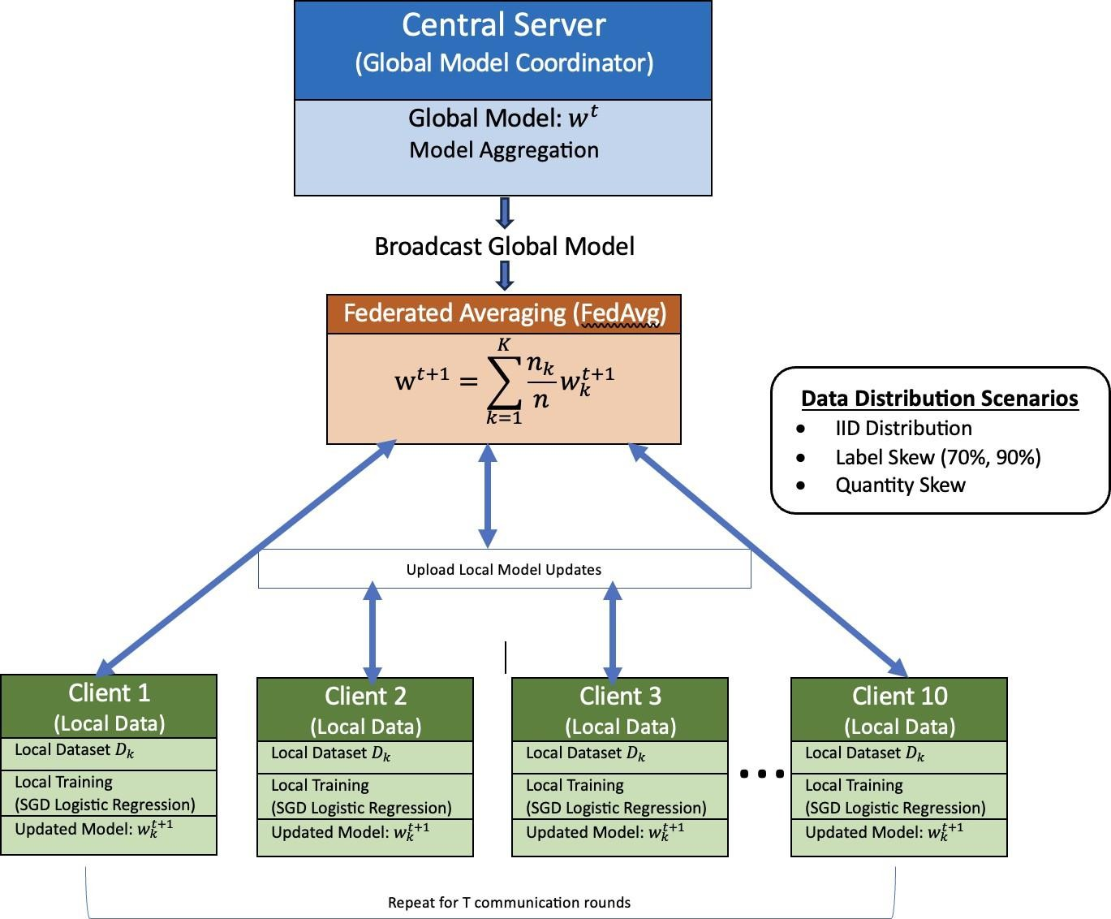
Figure 3.1: FL architecture using the FedAvg aggregation mechanism

At the beginning of each communication round 𝑡, the central server initializes or broadcasts the current global model 𝑤𝑡 to all participating clients. Each client then performs local training using its respective dataset 𝐷𝑘. In this study, the local training procedure utilizes stochastic gradient descent applied to a logistic regression model. After completing a predefined number

of local epochs, each client generates an updated local model 𝑤𝑡+1. Once local training is completed, the updated model parameters from all clients are transmitted back to the central server. The server then aggregates these updates using the Federated Averaging (FedAvg) algorithm to produce an improved global model. The aggregation step is defined as:
𝑘

𝑤𝑡+1 = ∑K nk 𝑤𝑡+1 (iv)
k=1 n 𝑘

where 𝑛𝑘 denotes the number of samples at client 𝑘 and 𝑛 represents the total number of samples across all participating clients. The updated global model is subsequently redistributed to the clients, and the training process continues iteratively for multiple communication rounds until convergence is achieved. The overall federated learning architecture used in this study is illustrated in Figure 3.1.

To provide a consolidated view of the methodology adopted in this study, Figure 3.2 illustrates the complete experimental pipeline. The workflow begins with the UCI Credit Card Default Dataset, followed by preprocessing and train–test splitting. A centralized logistic regression model is first developed as a performance baseline. The training data is then partitioned into multiple client datasets under IID and Non-IID configurations, including label skew and quantity skew scenarios. Federated training is subsequently conducted using the FedAvg and FedProx algorithms over 40 communication rounds. Finally, the resulting global models are evaluated using standard classification metrics, and their performance is compared across all experimental settings.

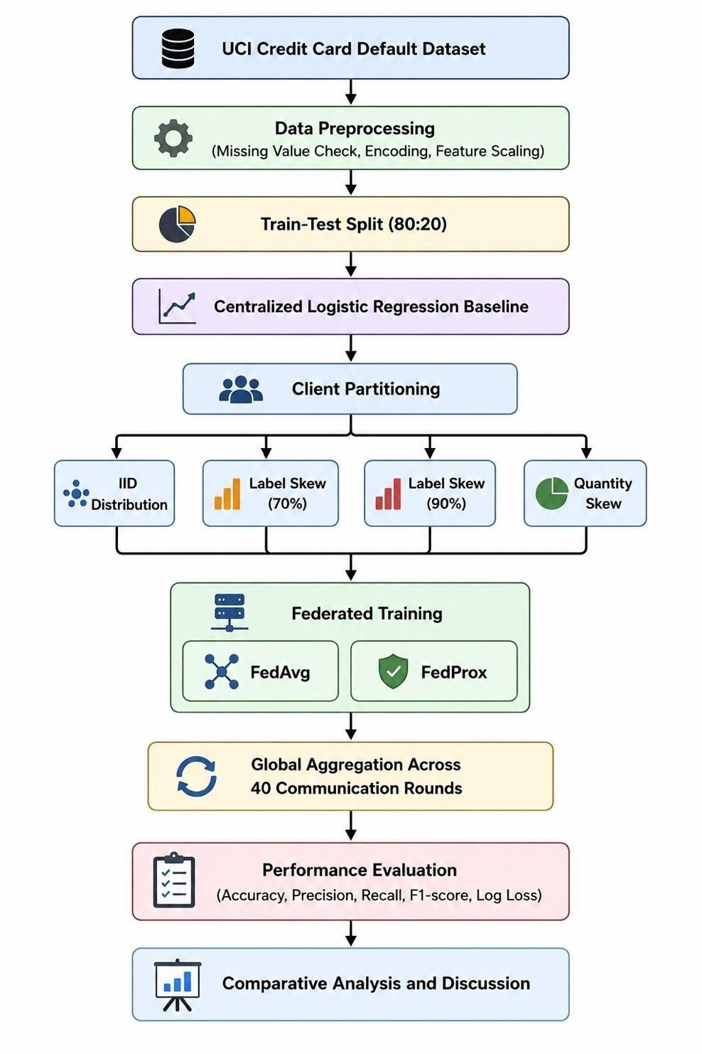

Figure 3.2: Experimental pipeline for federated learning-based credit default prediction

The experimental pipeline shown in Figure 3.2 summarizes the sequence of steps followed throughout this study. This structured approach ensures a consistent comparison between centralized and federated learning models and enables a systematic evaluation of the effects of different data distribution scenarios on model performance and convergence behavior.

Dataset and Preprocessing
This study utilizes the UCI Credit Card Default Dataset, which contains financial records of credit card clients and is commonly used for credit risk prediction research. The dataset consists

of 30,000 observations and 24 predictive attributes describing demographic characteristics, credit limits, repayment history, and billing statements of customers. The target variable indicates whether a client will default on payment in the following month.
Prior to model training, the dataset was separated into feature variables and the target variable representing the default status. The data was then divided into training and testing sets using an 80–20 split, ensuring that the class distribution was preserved through stratified sampling. This resulted in 24,000 training samples and 6,000 testing samples.
Since the dataset contains features with different numerical ranges, feature standardization was applied to ensure stable model optimization. The StandardScaler transformation was used to normalize each feature to zero mean and unit variance. This preprocessing step prevents features with larger magnitudes from dominating the learning process and improves the convergence behavior of gradient-based optimization algorithms.
The preprocessed training dataset was subsequently used for centralized baseline training as well as federated learning simulations under different client data distribution scenarios.

Client Data Partitioning Strategies
In federated learning environments, the distribution of data across clients plays a crucial role in determining the behavior and performance of the global model. In practical scenarios, client datasets often exhibit statistical heterogeneity, meaning that the data distributions across clients may differ significantly. To analyze the effect of such heterogeneity, this study evaluates the federated learning model under both IID and Non-IID data partitioning strategies.
Under the IID setting, the training dataset is randomly shuffled and divided into equal-sized partitions across the participating clients. This ensures that each client receives a dataset with approximately similar feature distributions and class proportions. In the experiments conducted in this study, the training dataset was divided among 10 clients, with each client receiving 2,400 samples. This setting simulates an ideal federated learning environment where local datasets are statistically similar.
To simulate real-world heterogeneity, two types of Non-IID distributions were introduced. The first scenario involves label skew, where the class distribution differs significantly across clients. In this configuration, certain clients receive a higher proportion of samples belonging to a particular class, resulting in imbalanced local datasets. Two levels of label skew were evaluated, namely 70% skew and 90% skew, to examine how increasing heterogeneity affects model convergence and performance.

The second scenario involves quantity skew, where the number of samples assigned to each client varies significantly. In this setup, a small number of clients possess a large portion of the dataset, while the remaining clients hold comparatively smaller subsets. This configuration reflects practical federated environments in which data availability may vary across participating devices or institutions.
These partitioning strategies enable a systematic evaluation of federated learning performance under varying degrees of statistical heterogeneity.

Model and Training Configuration
The predictive model used in this study is logistic regression, which is widely applied in credit risk prediction due to its interpretability and effectiveness for binary classification problems. In the federated learning setup, logistic regression was implemented using the SGDClassifier from the Scikit-learn library with the logistic loss function, enabling incremental model updates through stochastic gradient descent. During training, the dataset was distributed across 10 simulated clients, each performing local model updates using its respective partition of the training data. The federated learning process was executed for 40 communication rounds, where each round consisted of local client training followed by server-side aggregation of model parameters. To ensure stable optimization during federated training, the learning rate was set to 0.0005 using a constant learning rate schedule. Each client performed 10 local training epochs before transmitting its updated model parameters to the central server. The server then aggregated these parameters using the Federated Averaging (FedAvg) algorithm to update the global model.
All experiments were implemented in Python using the Scikit-learn, NumPy, and Pandas libraries. Model training and simulations were conducted on a personal computing environment using a MacBook with Apple M1 processor, ensuring efficient execution of federated learning experiments.

Evaluation Metrics
To evaluate the performance of the proposed federated learning framework, multiple classification metrics were used. Since credit default prediction involves imbalanced class distributions, relying solely on accuracy may not provide a complete assessment of model performance. Therefore, additional evaluation metrics including precision, recall, F1-score, and log loss were considered.

Accuracy measures the proportion of correctly classified instances among all predictions and is defined as:

𝑇𝑃 + 𝑇𝑁
𝐴𝑐𝑐𝑢𝑟𝑎𝑐𝑦 = 𝑇𝑃 + 𝑇𝑁 + 𝐹𝑃 + 𝐹𝑁

where 𝑇𝑃 represents true positives, 𝑇𝑁 denotes true negatives, 𝐹𝑃 indicates false positives, and 𝐹𝑁 represents false negatives.
Precision evaluates the proportion of correctly predicted positive instances among all predicted positives:

𝑇𝑃
𝑃𝑟𝑒𝑐𝑖𝑠𝑖𝑜𝑛 = 𝑇𝑃 + 𝐹𝑃

Recall, also known as sensitivity, measures the proportion of actual positive instances that are correctly identified by the model:

𝑇𝑃
𝑅𝑒𝑐𝑎𝑙𝑙 = 𝑇𝑃 + 𝐹𝑁

To balance precision and recall, the F1-score is used, which represents the harmonic mean of the two metrics:

𝑃𝑟𝑒𝑐𝑖𝑠𝑖𝑜𝑛 × 𝑅𝑒𝑐𝑎𝑙𝑙
𝐹1 = 2 × 𝑃𝑟𝑒𝑐𝑖𝑠𝑖𝑜𝑛 + 𝑅𝑒𝑐𝑎𝑙𝑙

In addition to classification metrics, logarithmic loss (log loss) was used to evaluate the probabilistic predictions of the model. Log loss measures the uncertainty of predicted probabilities and penalizes incorrect predictions with high confidence. Lower log loss values indicate better model performance.
These metrics collectively provide a comprehensive evaluation of model accuracy, prediction reliability, and convergence behavior across different federated learning scenarios.

RESULTS AND DISCUSSION

Centralized Baseline Performance
Before evaluating the federated learning framework, a centralized machine learning model was trained to establish a baseline for performance comparison. In this setup, the entire training dataset was used to train a logistic regression model implemented using stochastic gradient descent. The centralized model provides a reference point for assessing how distributed training under federated learning conditions affects predictive performance.
The centralized model was trained using the preprocessed dataset consisting of 24,000 training samples and evaluated on a test set containing 6,000 samples. The performance of the model was measured using accuracy, precision, recall, and F1-score.
Table 4.1 presents the performance metrics obtained from the centralized logistic regression model.

Table 4.1: Performance Metrics of the centralized logistic regression model

Metric | Value
Accuracy | 0.8072
Precision | 0.6941
Recall | 0.2291
F1-Score | 0.3445

Although the model achieves a relatively high accuracy of 80.72%, the recall value is significantly lower. This indicates that the model struggles to correctly identify a large portion of actual defaulters. In credit risk prediction, this behavior is often observed due to the class imbalance present in the dataset, where non-default cases significantly outnumber default cases.
To further analyze the classification behavior, the confusion matrix of the centralized model is shown in Figure 4.1.

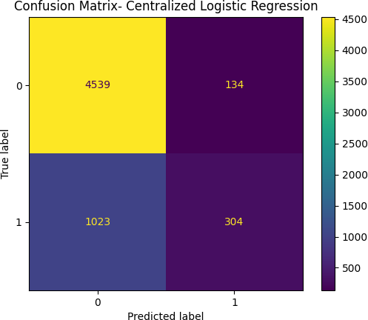
Figure 4.1: Confusion Matrix for the centralized logistic regression model

The confusion matrix reveals that the model correctly identifies 4,539 non-default cases, while 134 instances are incorrectly classified as defaults. However, among the actual default cases, the model correctly identifies only 304 instances, while 1,023 defaults are incorrectly classified as non-defaults. This results in a large number of false negatives, which explains the low recall score observed earlier.
These observations highlight an important limitation of the centralized model, particularly in identifying high-risk customers. The baseline results provide a useful benchmark for comparing the performance of federated learning models under different data distribution scenarios.

Federated Learning under IID Distribution
After establishing the centralized baseline, federated learning experiments were conducted under an Independent and Identically Distributed (IID) data setting. In this scenario, the training dataset was randomly shuffled and equally divided among the participating clients so that each client possessed approximately similar class distributions and feature characteristics. This configuration represents an ideal federated learning environment where the statistical properties of local datasets are consistent across clients.
In the experiment, the training dataset containing 24,000 samples was partitioned among 10 clients, with each client receiving 2,400 samples. Each client performed local training using stochastic gradient descent for 10 local epochs, after which the locally updated models were transmitted to the central server. The server aggregated the client updates using the Federated

Averaging (FedAvg) algorithm to produce the updated global model. This process was repeated for 40 communication rounds.
The performance metrics obtained from the federated learning model under IID distribution are presented in Table 4.2.

Table 4.2: Performance metrics of Federated Learning under IID data distribution

Metric | Value
Accuracy | 0.8080
Precision | 0.6898
Recall | 0.2396
F1-Score | 0.3557
Log Loss | 0.4710

The results indicate that the federated model achieves a performance comparable to the centralized baseline model. The final accuracy of 0.8080 is slightly higher than the centralized model accuracy of 0.8072, suggesting that federated training under IID conditions can achieve similar predictive capability while maintaining data decentralization.
To further analyze the learning behavior of the federated model, the convergence of accuracy and loss over communication rounds is illustrated in Figure 4.2.1 and Figure 4.2.2 respectively.
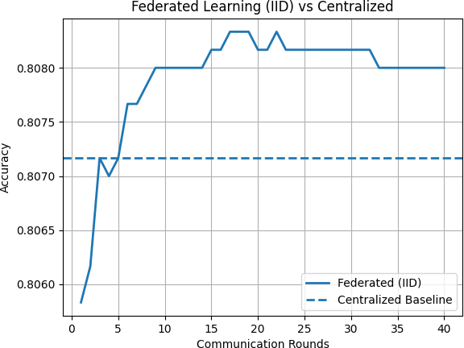
Figure 4.2.1: Accuracy convergence of Federated Learning under IID distribution

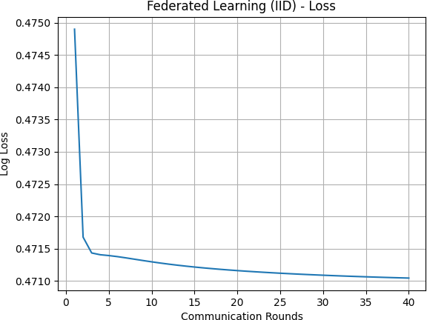

Figure 4.2.2: Log loss convergence of Federated Learning under IID distribution

The convergence plots show that the global model stabilizes after approximately 10–15 communication rounds, after which only minor fluctuations in accuracy and loss are observed. This behavior indicates that when client datasets follow similar distributions, the federated averaging algorithm is able to aggregate model updates effectively and achieve stable convergence.
These results confirm that federated learning can match centralized learning performance when the data distribution across clients remains statistically consistent.

Impact of Label Skew on Federated Learning
In real-world federated learning environments, client datasets often exhibit statistical heterogeneity, where the distribution of classes varies significantly across participating clients. One common form of heterogeneity is label skew, in which some clients possess datasets dominated by a particular class while other clients contain a different class distribution. Such conditions can significantly influence the behavior of federated optimization algorithms.
To investigate the effect of label skew on federated learning performance, two experimental scenarios were evaluated in this study: moderate skew (70%) and severe skew (90%). In both cases, the overall training dataset was partitioned among the participating clients in such a way that each client received a dataset with an imbalanced class distribution. These experiments were designed to simulate practical federated environments where clients may observe different data characteristics due to geographical, demographic, or institutional variations.

The performance of the federated model under these heterogeneous conditions was analyzed using the evaluation metrics defined in Chapter 3, along with convergence behavior across communication rounds.

Moderate Label Skew (70%)
In the moderate skew experiment, each client dataset was constructed such that approximately 70% of the samples belonged to a dominant class, while the remaining 30% belonged to the minority class. This configuration introduces noticeable heterogeneity among client datasets while still allowing some overlap in class distributions.
The final performance metrics obtained under the 70% label skew scenario are summarized in Table 4.3.1.

Table 4.3.1: Performance metrics of Federated Learning under 70% Label Skew

Metric | Value
Accuracy | 0.6693
Precision | 0.3585
Recall | 0.6270
F1-Score | 0.4561
Log Loss | 0.6107

Compared to the IID federated learning scenario, the overall accuracy drops significantly from approximately 0.808 to 0.669, indicating that statistical heterogeneity negatively affects the aggregation process. This performance degradation occurs because local models trained on imbalanced datasets tend to produce biased gradient updates, which may conflict with updates from other clients during the aggregation phase.
Interestingly, while accuracy decreases, the recall value increases substantially to 0.627, indicating that the model becomes more sensitive to detecting default cases. This behavior highlights a trade-off between accuracy and recall, where the model becomes more sensitive to detecting default cases at the cost of increased false positives. This also suggests a shift in the decision boundary toward the default class due to biased local training.

The convergence behavior of the model under this setting is illustrated in Figure 4.3.1.1 and Figure 4.3.1.2, which show the accuracy and loss trends across communication rounds.

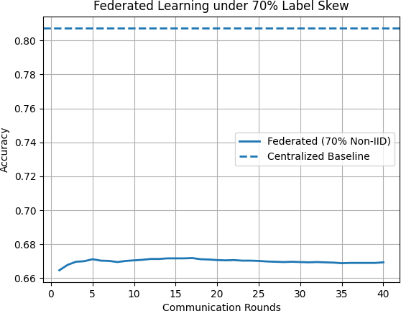

Figure 4.3.1.1: Accuracy convergence under 70% label skew
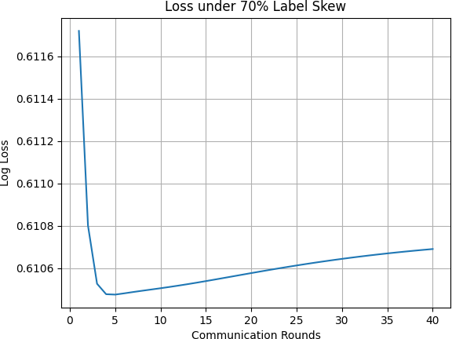

Figure 4.3.1.2: Log loss convergence under 70% label skew

The plots indicate that the model stabilizes after approximately 10–15 communication rounds, although the final accuracy remains substantially lower than the IID case.

Severe Label Skew (90%)
To further examine the effect of increasing heterogeneity, a severe label skew scenario (90%) was evaluated. In this configuration, each client dataset was constructed such that approximately 90% of the samples belonged to a single class, creating highly imbalanced local datasets.

The final performance metrics for this scenario are presented in Table 4.3.2.

Table 4.3.2: Performance metrics of Federated Learning under 90% Label Skew

Metric | Value
Accuracy | 0.6438
Precision | 0.3415
Recall | 0.6579
F1-Score | 0.4497
Log Loss | 0.6170

Compared to the moderate skew scenario, the accuracy decreases further to 0.6438, demonstrating that increased heterogeneity leads to additional degradation in model performance. The severe imbalance across client datasets causes stronger divergence between local model updates, resulting in conflicting gradients during aggregation.
However, the recall value increases slightly to 0.6579, indicating that the model continues to prioritize the detection of default cases. The increasing divergence between local updates indicates stronger client drift, where local models move further away from the global objective. This results in a noticeable shift in the decision boundary and further degradation in global model performance.
The convergence behavior under severe skew conditions is illustrated in Figure 4.3.2.1 and Figure 4.3.2.2.
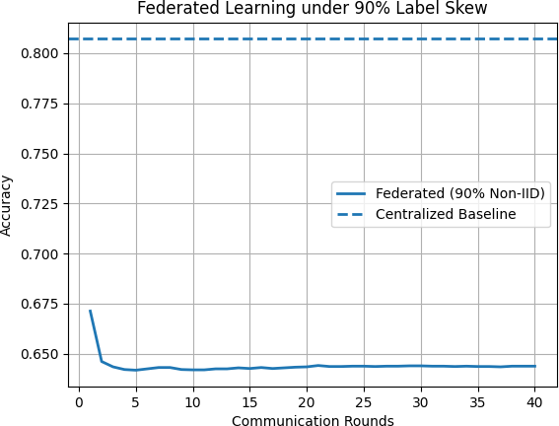
Figure 4.3.2.1: Accuracy convergence under 90% label skew

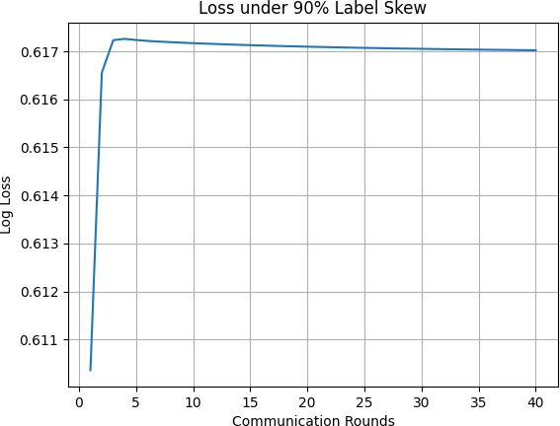

Figure 4.3.2.2: Log loss convergence under 90% label skew

The results demonstrate that as data heterogeneity increases, the performance of the federated learning model deteriorates due to inconsistent local updates and client drift effects.

Impact of Quantity Skew on Federated Learning
In addition to label skew, another form of heterogeneity commonly observed in federated learning environments is quantity skew, where the number of samples available at each client varies significantly. In real-world deployments, certain participants may possess substantially larger datasets than others due to differences in data collection capabilities or operational scale. To examine the effect of this scenario, a quantity skew experiment was conducted in which the dataset was distributed unevenly across the participating clients. In this configuration, a small number of clients received a large portion of the training samples, while the remaining clients were assigned comparatively smaller datasets. Specifically, two clients were assigned 8,000 samples each, whereas the remaining eight clients received 1,000 samples each.
The performance metrics obtained under the quantity skew scenario are summarized in Table 4.4.

Table 4.4: Performance metrics of Federated Learning under Quantity Skew

Metric | Value
Accuracy | 0.8080
Precision | 0.6993
Recall | 0.2313
F1-Score | 0.3477
Log Loss | 0.4711

The results indicate that the federated learning model maintains performance levels comparable to the IID setting, with accuracy remaining approximately 0.808. This suggests that quantity skew does not significantly affect model performance in this scenario. The primary reason for this behavior is that, despite differences in dataset size, the underlying class distribution across clients remains consistent. As a result, local models are trained on statistically similar data distributions, leading to gradients that are well-aligned during aggregation. Consequently, the global optimization process remains stable, and the model converges effectively.
Although clients with larger datasets contribute more heavily to the global model due to weighted aggregation, this does not introduce instability because their updates are consistent with those of smaller clients. Therefore, quantity skew affects the magnitude of contribution rather than the direction of optimization.
The convergence behavior of the model under quantity skew is illustrated in Figure 4.4.1 and Figure 4.4.2.
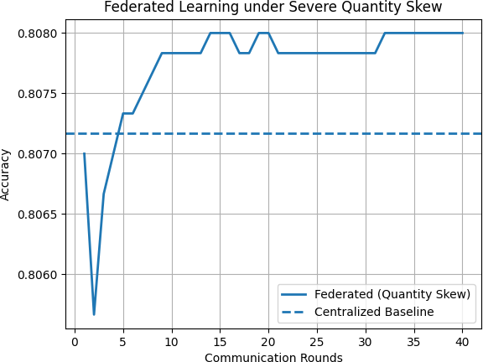
Figure 4.4.1: Accuracy convergence under Quantity Skew

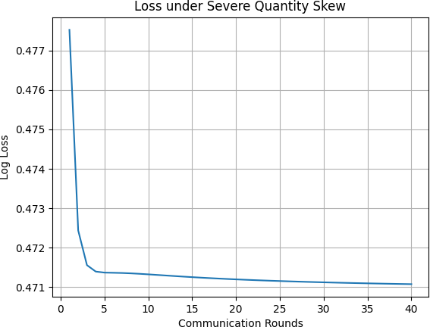

Figure 4.4.2: Log loss convergence under Quantity Skew

These observations highlight a key distinction between different types of data heterogeneity in federated learning. While label skew alters the learning objective and leads to conflicting gradients, quantity skew primarily influences contribution levels without significantly affecting convergence behavior.
Overall, these results demonstrate that heterogeneity in class distribution has a significantly greater impact on federated learning performance than heterogeneity in data quantity.

To provide a clearer overview of the experimental results obtained across different data distribution scenarios, Table 4.4.2 summarizes the performance of the centralized model and the federated learning models under IID, label skew, and quantity skew settings.

Table 4.4.2: Comparative Performance of Centralized and Federated Learning under different data distributions

Scenario | Accuracy | Precision | Recall | F1-Score | Log Loss
Centralized Baseline | 0.8072 | 0.6941 | 0.2291 | 0.3445 | -
Federated Learning (IID) | 0.8080 | 0.6898 | 0.2396 | 0.3557 | 0.4710
FL with 70% Label Skew | 0.6693 | 0.3585 | 0.6270 | 0.4561 | 0.6107
FL with 90% Label Skew | 0.6438 | 0.3415 | 0.6579 | 0.4497 | 0.6170
FL with Quantity Skew | 0.8080 | 0.6993 | 0.2313 | 0.3477 | 0.4711

The comparison highlights that federated learning achieves performance comparable to centralized training under IID conditions. However, significant performance degradation

occurs under label skew scenarios due to heterogeneous class distributions across clients. In contrast, quantity skew has minimal impact on model performance because the class distribution across clients remains relatively balanced.

Comparative Analysis (FedAvg vs FedProx)
This section presents a comparative analysis between the Federated Averaging (FedAvg) algorithm and the Federated Proximal (FedProx) algorithm under heterogeneous data distributions. The primary objective of this comparison is to evaluate whether FedProx can mitigate the performance degradation observed in federated learning under Non-IID conditions, particularly in scenarios involving label skew.
The comparison is conducted under two levels of data heterogeneity: moderate label skew (70%) and severe label skew (90%). The performance of both algorithms is analyzed using standard evaluation metrics along with their convergence behavior across communication rounds.

Comparison under Moderate Label Skew (70%)
In the moderate label skew scenario, each client dataset contains approximately 70% samples from a dominant class and 30% from the minority class. This setup introduces noticeable heterogeneity while still preserving some overlap in class distributions across clients.
The performance metrics obtained for both FedAvg and FedProx under this setting are presented in Table 4.5.1.
Table 4.5.1: Performance comparison of FedAvg and FedProx under 70% Label Skew

Metric | FedAvg | FedProx
Accuracy | 0.6693 | 0.6702
Precision | 0.3585 | 0.3591
Recall | 0.6270 | 0.6262
F1-Score | 0.4561 | 0.4565
Log Loss | 0.6107 | 0.6104

The results indicate that both algorithms exhibit nearly identical performance under moderate heterogeneity. FedProx achieves a marginal improvement in accuracy and F1-score, while also slightly reducing the log loss compared to FedAvg. However, the magnitude of improvement

is minimal, suggesting that under moderate label skew, the divergence between local client updates is not sufficiently large to significantly impact the aggregation process.
The convergence behavior of both algorithms is illustrated in Figure 4.5.1.1 and Figure 4.5.1.2.

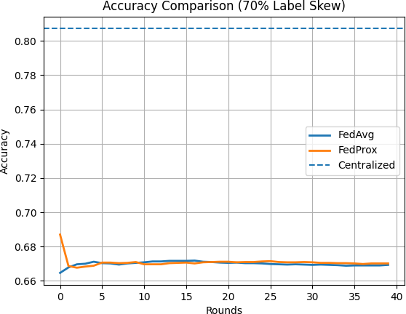
Figure 4.5.1.1: Accuracy comparison between FedAvg and FedProx under 70% label skew

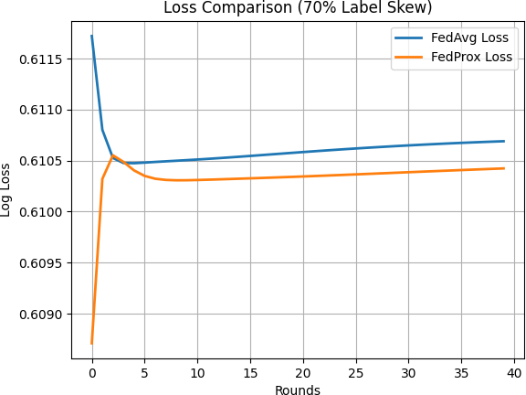
Figure 4.5.1.2: Log loss comparison between FedAvg and FedProx under 70% label skew

The plots demonstrate that the learning trajectories of FedAvg and FedProx are almost overlapping throughout the communication rounds. Both models stabilize after approximately 10–15 rounds, with only minor fluctuations thereafter. This behavior indicates that when

heterogeneity is moderate, the proximal regularization term in FedProx does not significantly alter the optimization path.
These observations suggest that FedAvg is sufficiently robust under moderate Non-IID conditions, and the additional regularization introduced by FedProx provides only limited benefit in such scenarios.

Comparison under Severe Label Skew (90%)
To further investigate the impact of heterogeneity, the comparison was extended to a severe label skew scenario in which each client dataset contains approximately 90% samples from a single class. This configuration introduces strong statistical heterogeneity and significantly increases the divergence between local client updates.
The performance metrics for both algorithms under this setting are presented in Table 4.5.2.

Table 4.5.2: Performance comparison of FedAvg and FedProx under 90% Label Skew

Metric | FedAvg | FedProx
Accuracy | 0.6438 | 0.6478
Precision | 0.3415 | 0.3433
Recall | 0.6579 | 0.6488
F1-Score | 0.4497 | 0.4490
Log Loss | 0.6170 | 0.6157

In contrast to the moderate skew scenario, a more noticeable difference in performance is observed under severe heterogeneity. FedProx achieves a higher accuracy and lower log loss compared to FedAvg, indicating improved stability and better optimization under highly Non-IID conditions.
Although the improvement in F1-score is marginal, the reduction in log loss suggests that FedProx produces more consistent probabilistic predictions. This behavior can be attributed to the proximal term in FedProx, which constrains local model updates to remain closer to the global model, thereby reducing the effect of client drift.
The convergence behavior under severe label skew is illustrated in Figure 4.5.2.1 and Figure 4.5.2.2.

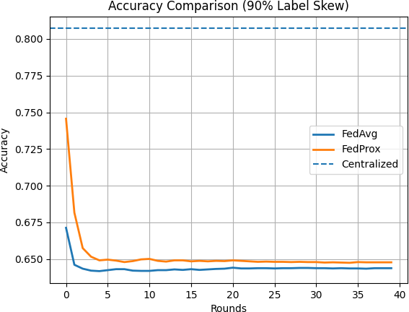

Figure 4.5.2.1: Accuracy comparison between FedAvg and FedProx under 90% label skew

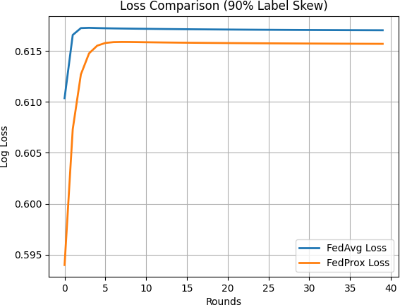

Figure 4.5.2.2: Log loss comparison between FedAvg and FedProx under 90% label skew

The plots reveal a clear distinction between the two algorithms during the initial communication rounds. FedProx demonstrates a more stable convergence trajectory, whereas FedAvg exhibits sharper fluctuations due to conflicting local updates. As training progresses, both models stabilize; however, FedProx consistently maintains a slight performance advantage.

These results highlight the effectiveness of FedProx in handling severe data heterogeneity by mitigating the divergence of local models.

Convergence Behavior Analysis
A comparative analysis of convergence patterns across both scenarios reveals that the effectiveness of FedProx is closely tied to the degree of heterogeneity in the data distribution. Under moderate label skew (70%), both FedAvg and FedProx exhibit similar convergence rates and stability, indicating that the optimization landscape remains relatively smooth. In this case, local updates from different clients are not highly conflicting, allowing FedAvg to perform effectively without additional regularization.
However, under severe label skew (90%), the divergence between local updates becomes more pronounced. This results in unstable aggregation in FedAvg, leading to fluctuations in performance. FedProx addresses this issue by introducing a proximal term that penalizes large deviations from the global model, thereby stabilizing the training process.
This behavior can be interpreted as a trade-off between flexibility and stability. While FedAvg allows unrestricted local updates, FedProx imposes a constraint that limits local deviation, making it more suitable for highly heterogeneous environments.

Overall Discussion and Insights
The comparative analysis demonstrates that the performance of federated optimization algorithms is strongly influenced by the degree of data heterogeneity across clients.
Under moderate Non-IID conditions, both FedAvg and FedProx achieve comparable performance, indicating that simple averaging is sufficient when client distributions are not highly divergent. However, as heterogeneity increases, the limitations of FedAvg become more apparent, particularly due to client drift and conflicting gradient updates.
FedProx partially mitigates these issues by constraining local updates, resulting in improved stability and slightly better performance under severe label skew. Nevertheless, the overall improvement remains modest, which can be attributed to the use of a relatively simple model (logistic regression) that has limited capacity to capture complex patterns in highly heterogeneous data.
Another important observation is that both federated approaches perform significantly worse than the centralized baseline under Non-IID conditions. This highlights a fundamental challenge in federated learning, where data decentralization introduces optimization difficulties that are not present in centralized training.

Overall, the results suggest that while FedProx provides a meaningful improvement over FedAvg in highly heterogeneous settings, further advancements in model design and optimization strategies are required to bridge the performance gap between federated and centralized learning.

Table 4.5.4: Comparative Characteristics of FedAvg and FedProx

Aspect | FedAvg | FedProx
Optimization Strategy | Simple parameter averaging | Proximal Regularization
Handles Non-IID Data | Moderate | Better
Computational Complexity | Lower | Slightly higher
Stability under Severe Skew | Lower | Higher
Performance Gain in this study | Baseline | Marginal Improvement

Explainability Considerations for Federated Credit Risk Models
In credit risk prediction, model performance alone is not sufficient for practical deployment. Financial institutions are often required to justify automated lending decisions to customers, auditors, and regulatory authorities. As a result, predictive models must not only achieve strong classification performance but also provide explanations that describe how specific input features influence the final decision. This requirement becomes particularly important in privacy-sensitive environments where collaborative learning is performed without sharing raw data.
Traditional credit scoring models such as logistic regression are generally considered interpretable because the contribution of each feature can be examined through the learned model coefficients. However, in a federated learning setting, interpretability becomes more challenging because the global model is derived from aggregated updates obtained from multiple clients with heterogeneous local data distributions. Consequently, the influence of individual features may vary across clients, making it more difficult to understand how the final global model reaches its predictions.
Explainable Artificial Intelligence (XAI) techniques provide a practical solution to this challenge. Methods such as Local Interpretable Model-agnostic Explanations (LIME) and

SHapley Additive exPlanations (SHAP) are widely used to explain model predictions by estimating the contribution of each feature to a particular decision. In credit risk prediction, these techniques can identify which variables, such as repayment status, credit utilization, and bill amounts, most strongly influence the probability of default.
In the context of federated learning, explainability can be applied after training the global model. Once the aggregated model is obtained, explanation techniques can be used to analyze individual predictions on a validation or test dataset. This enables practitioners to verify whether the model relies on financially meaningful variables and to assess whether its decisions are consistent with domain knowledge. Such analysis can increase trust in federated models and support regulatory compliance requirements.
Explainability also offers an additional mechanism for understanding the impact of data heterogeneity. Under highly Non-IID conditions, local models may learn different decision boundaries due to variations in class distributions across clients. By comparing feature importance patterns across different experimental scenarios, researchers can investigate whether heterogeneous data causes the global model to emphasize different predictors. This provides deeper insight into how client-level statistical differences influence the behavior of federated models beyond standard performance metrics.
Although the present study focuses primarily on predictive performance and convergence behavior, the integration of explainability techniques represents a natural extension of this work. Applying LIME or SHAP to the federated models developed in this study would enable a more comprehensive evaluation by combining performance analysis with interpretability. This would be particularly valuable in financial applications, where transparent and accountable decision-making is essential.
Overall, explainability is a critical component for the practical adoption of federated learning in credit risk prediction. While federated learning addresses privacy concerns by keeping data decentralized, explainable AI techniques help ensure that the resulting models remain transparent, trustworthy, and suitable for deployment in regulated financial environments.

Practical Implications for Financial Institutions
The findings of this study have important implications for financial institutions seeking to develop collaborative credit risk models while preserving customer privacy. Banks and lending organizations often possess valuable but isolated datasets that cannot be shared directly because of regulatory requirements, confidentiality obligations, and competitive concerns. Federated learning provides a practical framework for addressing this challenge by enabling institutions

to train a common predictive model without transferring raw customer records to a central server.
The experimental results indicate that federated learning can achieve competitive performance under IID conditions, but its effectiveness declines as the degree of data heterogeneity increases. In particular, severe label skew and quantity skew lead to noticeable reductions in accuracy and increases in prediction loss. This suggests that institutions participating in federated training should carefully evaluate the distributional characteristics of their local datasets before deploying such systems in production environments.
The comparative analysis of FedAvg and FedProx demonstrates that optimization strategies designed for heterogeneous settings can provide modest improvements when client data distributions are highly imbalanced. Under severe label skew, FedProx achieved slightly higher accuracy and lower loss than FedAvg, indicating that proximal regularization can improve training stability. However, the magnitude of improvement was relatively small, implying that algorithmic enhancements alone may not fully overcome the challenges introduced by extreme statistical heterogeneity.
From an operational perspective, these results suggest that federated learning is most effective when participating institutions exhibit reasonably similar customer populations and default patterns. When data heterogeneity is substantial, additional techniques such as personalized federated learning, adaptive client weighting, or transfer learning may be required to achieve robust performance. Institutions should therefore treat federated learning as a flexible framework rather than a universally optimal solution.
The study also highlights a fundamental trade-off between privacy preservation and predictive performance. Centralized learning consistently outperformed federated approaches because it had access to the complete training dataset and could optimize a single model without the constraints imposed by decentralized training. Financial institutions must weigh this performance gap against the benefits of improved privacy, regulatory compliance, and reduced data-sharing risk.
Overall, the results demonstrate that federated learning is a viable approach for privacy-preserving credit risk prediction, particularly when data distributions across institutions are not excessively heterogeneous. The comparative evaluation of FedAvg and FedProx provides practical guidance for selecting optimization methods based on the severity of Non-IID conditions and the performance requirements of real-world financial applications.

Summary of Experimental Findings
The experimental results discussed throughout this chapter demonstrate the effects of different data distributions and optimization strategies on federated credit risk prediction. To provide a consolidated view of the key findings, Table 4.8 summarizes the best-performing methods and their corresponding performance metrics across all experimental scenarios considered in this study.

Table 4.8: Overall Performance Summary Across Experimental Scenarios

Experimental Scenario | Best Performing Method | Accuracy | F1-Score | Remarks
Centralized Learning | Centralized Logistic Regression | 0.8072 | 0.3445 | Highest overall performance
IID Federated Learning | FedAvg / FedProx | 0.8080 | 0.3557 | Comparable to centralized
70% Label Skew | FedProx | 0.6702 | 0.4565 | Marginal improvement over FedAvg
90% Label Skew | FedProx | 0.6478 | 0.4490 | Better resilience under severe skew
Quantity Skew | FedAvg | 0.8080 | 0.3477 | Performance remained comparable to IID

The summary presented in Table 4.8 highlights the consistent superiority of centralized learning while demonstrating that FedProx offers improved robustness over FedAvg under highly heterogeneous data distributions. FedProx was not evaluated under the quantity skew setting, as FedAvg demonstrated performance comparable to the IID case.

CONCLUSION AND FUTURE WORK

Summary of Findings
This study investigated the performance of federated learning for credit default prediction under different data distribution scenarios using the UCI Credit Card dataset. A centralized logistic regression model was first developed as a baseline, followed by multiple federated learning experiments using the Federated Averaging (FedAvg) and Federated Proximal (FedProx) algorithms. The primary objective was to examine how data heterogeneity affects federated optimization and model performance.
The centralized baseline model achieved an accuracy of 0.8072, providing the highest overall predictive performance among all experimental settings. This result confirms that centralized training remains advantageous when complete access to globally aggregated data is available, as the model can learn from the full statistical distribution without fragmentation across clients. Under IID federated conditions, the FedAvg model achieved performance nearly identical to the centralized baseline, with an accuracy of approximately 0.8080. This demonstrates that federated learning can successfully replicate centralized learning performance when client datasets are statistically similar. The convergence curves also indicated stable optimization with rapid convergence after the initial communication rounds.
The study further examined the effect of label skew, a common form of statistical heterogeneity in federated environments. Under moderate label skew (70%), the accuracy of the federated model decreased substantially to approximately 0.6693, while recall increased to 0.6270. This indicates that heterogeneous client distributions negatively affect global optimization, causing reduced overall accuracy but greater sensitivity toward detecting default cases.
When the degree of heterogeneity was increased to severe label skew (90%), performance declined further, with FedAvg achieving an accuracy of 0.6438. This confirms that stronger Non-IID conditions intensify client drift, resulting in conflicting local updates and suboptimal aggregation. The results clearly demonstrate that label skew is a major challenge for federated learning systems.
The quantity skew experiment showed a contrasting behavior. Despite uneven data volume across clients, federated learning performance remained comparable to the IID setting, with accuracy close to 0.8080. This suggests that variations in client dataset size are less harmful when the underlying class distribution remains statistically consistent. Therefore, class-distribution heterogeneity has a much greater effect on performance than sample-size heterogeneity.

A comparative analysis between FedAvg and FedProx was conducted under heterogeneous settings. Under 70% label skew, both algorithms achieved nearly similar performance, indicating limited benefit of proximal regularization under moderate heterogeneity. However, under 90% label skew, FedProx achieved higher accuracy (0.6478) and lower log loss (0.6157) than FedAvg. This demonstrates that FedProx is more effective in highly Non-IID environments, where constraining local updates helps reduce client drift and improves training stability.
Overall, the findings of this study establish three important conclusions. First, federated learning can match centralized learning performance under IID data distributions. Second, statistical heterogeneity—particularly label skew—causes substantial degradation in federated model performance. Third, optimization methods such as FedProx can partially mitigate these effects under severe Non-IID conditions, although a noticeable performance gap with centralized learning still remains.
These results highlight the practical trade-off in federated learning between privacy-preserving decentralized training and predictive performance, emphasizing the need for more robust algorithms for real-world heterogeneous environments.

Limitations
Although this study provides useful insights into the performance of federated learning under different data heterogeneity scenarios, certain limitations should be acknowledged. The experiments were conducted using a logistic regression model implemented through stochastic gradient descent. While logistic regression is computationally efficient and easy to interpret, it is a relatively simple linear model with limited ability to capture complex nonlinear relationships that may exist in financial risk data. More advanced models such as neural networks or ensemble methods may produce different outcomes.
The study was based on a single benchmark dataset, namely the UCI Credit Card Default dataset. Although widely used in research, this dataset represents a specific domain and population. Therefore, the findings may not fully generalize to other financial datasets, institutions, or customer segments with different characteristics. The federated learning environment was simulated by partitioning a centralized dataset into multiple clients. In real-world deployments, clients may have dynamic data, inconsistent quality, missing values, and changing participation patterns. As a result, practical federated systems may experience additional challenges beyond those captured in the present experiments.

Only two forms of heterogeneity, label skew and quantity skew, were examined in this study. Other important Non-IID conditions such as feature distribution shift, concept drift, and temporal changes were not included, even though they may significantly affect federated optimization and convergence.
The comparative analysis was limited to FedAvg and FedProx. While these are widely recognized baseline methods, more advanced approaches such as SCAFFOLD, FedNova, or personalized federated learning techniques may offer stronger robustness under highly heterogeneous settings.
Communication constraints and system-level factors were also outside the scope of this work. Issues such as bandwidth limitations, client dropout, asynchronous participation, and device resource constraints can influence the efficiency of federated training in real deployments.
The study primarily focused on predictive performance metrics including accuracy, precision, recall, F1-score, and log loss. Practical credit risk systems may additionally require fairness assessment, calibration analysis, explainability, and regulatory compliance, which were not explored in detail.
Despite these limitations, the study offers a structured experimental foundation for understanding how data heterogeneity affects federated learning performance in credit default prediction.

Future Directions
Several directions may be explored to extend the findings of this study and improve the applicability of federated learning for credit risk prediction. Future work may evaluate more advanced machine learning models such as deep neural networks, gradient boosting methods, or hybrid architectures to determine whether stronger predictive models can reduce the performance gap between federated and centralized learning. Additional federated optimization techniques such as SCAFFOLD, FedNova, adaptive aggregation methods, and personalized federated learning approaches may also be investigated for handling highly heterogeneous client data.
Further studies may incorporate more realistic Non-IID conditions including feature distribution shift, concept drift, temporal variation, and partial client participation. Testing the framework on multiple real-world financial datasets would also improve the generalizability of the results. Another important direction is the integration of privacy-preserving mechanisms such as differential privacy, secure aggregation, and encrypted communication to strengthen data confidentiality during training.

Finally, future research may focus on explainable federated learning by integrating interpretability techniques such as LIME or SHAP. This would help financial institutions understand model decisions, improve trustworthiness, and support regulatory compliance in credit risk assessment systems.

REFERENCES:

- M. Naganna, G. R. Nayaka, N. Mahadev, and M. Tapkire, “FedProx-enhanced federated transfer learning for heterogeneous 3D medical image classification,” Journal of Computational and Cognitive Engineering, 2026, doi: 10.47852/bonviewJCCE62027069.

- Y. Chen, K. Zhang, H. Zhu, and Z. Qiu, “A novel federated transfer learning framework for credit card fraud detection under heterogeneous data conditions,” MDPI, Risks, vol. 13, p. 208, 2025, doi: 10.3390/risks13110208.

- M. Emmanuel, “Federated learning for privacy-preserving financial fraud detection,” 2025.

- B. Claus, A. John, and A. John, “Federated learning for collaborative fraud detection in financial networks: Addressing data privacy concerns,” 2025.

- A. Asl Nemati, M. H. Sadreddini, and M. Mahdizade, “Comparative federated algorithms for solving non-IID data challenges,” System Analytics, Transactions on Soft Computing, vol. 1, no. 1, pp. 27–35, 2025, doi: 10.48314/tsc.v1i1.35.

- S. Pingulkar and D. Pawade, “Federated learning architectures for credit risk assessment: A comparative analysis of vertical, horizontal, and transfer learning approaches,” IEEE, 2024, doi: 10.1109/ICBDS61829.2024.10837430.

- Y. Tang and Y. Liang, “Credit card fraud detection based on federated graph learning,” Elsevier, Expert Systems with Applications, vol. 256, p. 124979, 2024, doi: 10.1016/j.eswa.2024.124979.

- D. M. Jimenez G., D. Solans, M. A. Heikkilä, A. Vitaletti, N. Kourtellis, A. Anagnostopoulos, and I. Chatzigiannakis, “Non-IID data in Federated Learning: A Survey with Taxonomy, Metrics, Methods, Frameworks and Future Directions,” IEEE, IEEE Communications Surveys & Tutorials, vol. 00, no. 00, pp. 1–25, 2024, doi: Pending / not listed in uploaded version.

- X. Sha, “Research on financial fraud algorithm based on federal learning and big data technology,” in Proceedings of the 2024 IEEE 2nd International Conference on Sensors, Electronics and Computer Engineering, IEEE, pp. 743–748, 2024.

- H. T. Lin and C. Y. Wen, “Edge federated optimization for heterogeneous data,” MDPI, Future Internet, vol. 16, no. 4, 2024, doi: 10.3390/fi16040142.

- H. Guan, P. T. Yap, A. Bozoki, and M. Liu, “Federated learning for medical image analysis: A survey,” Elsevier, Pattern Recognition, 2024, doi: 10.1016/j.patcog.2024.110424.

- Z. Wang, J. Xiao, L. Wang, and J. Yao, “A novel federated learning approach with knowledge transfer for credit scoring,” Elsevier, Decision Support Systems, vol. 177, 2024, doi: 10.1016/j.dss.2023.114084.

- M. Abdul Salam, K. M. Fouad, D. L. Elbably, and S. M. Elsayed, “Federated learning model for credit card fraud detection with data balancing techniques,” Springer, Neural Computing and Applications, vol. 36, no. 11, pp. 6231–6256, 2024, doi: 10.1007/s00521-023-
09410-2.

- M. Gecer and B. Garbinato, “Federated learning for mobility applications,” ACM, ACM Computing Surveys, vol. 56, no. 5, 2024, doi: 10.1145/3637868.

- M. Haller, C. Lenz, R. Nachtigall, F. M. Awayshehl, and S. Alawadi, “Handling Non-IID data in federated learning: An experimental evaluation towards unified metrics,” IEEE, 2023, doi: 10.1109/DASC/PiCom/CBDCom/Cy59711.2023.10361408.

- L. Che, J. Wang, Y. Zhou, and F. Ma, “Multimodal federated learning: A survey,” MDPI, Sensors, vol. 23, no. 15, 2023, doi: 10.3390/s23156986.

- “Federated learning for credit risk assessment,” Proceedings of the 56th Hawaii International Conference on System Sciences, 2023.

- A. Brecko, E. Kajati, J. Koziorek, and I. Zolotova, “Federated learning for edge computing: A survey,” MDPI, Applied Sciences, 2022, doi: 10.3390/app12189124.

- Y. Zhao, M. Li, L. Lai, N. Suda, D. Civin, and Y. Chandra, “Federated learning with Non-IID data,” arXiv, 2022, doi: 10.48550/arXiv.1806.00582.

- D. H. Mahlool and M. H. Abed, “A Comprehensive Survey on Federated Learning: Concept and Applications,” AL-Qadisiyah University, College of Computer Science and Information Technology, Jul. 2022.

- Q. Li, Y. Diao, Q. Chen, and B. He, “Federated learning on Non-IID data silos: An experimental study,” IEEE, Proceedings of ICDE, pp. 965–978, 2022, doi: 10.1109/ICDE53745.2022.00077.

- A. M. Abdelmoniem, C. Y. Ho, P. Papageorgiou, and M. Canini, “Empirical analysis of federated learning in heterogeneous environments,” ACM, EuroMLSys, 2022.

- S. Bharati, M. R. H. Mondal, P. Podder, and V. B. S. Prasath, “Federated learning: Applications, challenges and future directions,” International Journal of Hybrid Intelligent Systems, vol. 18, pp. 19–35, 2022, doi: 10.3233/HIS-220006.

- B. Yu, W. Mao, Y. Lv, C. Zhang, and Y. Xie, “A survey on federated learning in data mining,” Wiley, WIREs Data Mining and Knowledge Discovery, 2022, doi: 10.1002/widm.1443.

- R. Xu, N. Baracaldo, Y. Zhou, A. Anwar, J. Joshi, and H. Ludwig, “FedV: Privacy-preserving federated learning over vertically partitioned data,” ACM, AISec, pp. 181–192, 2021, doi: 10.1145/3474369.3486872.

- H. Zhu, J. Xu, S. Liu, and Y. Jin, “Federated learning on Non-IID data: A survey,” Elsevier, Neurocomputing, vol. 465, pp. 371–390, 2021, doi: 10.1016/j.neucom.2021.07.098.

- K. M. Jawadur Rahman et al., “Challenges, applications and design aspects of federated learning: A survey,” IEEE Access, 2021, doi: 10.1109/ACCESS.2021.3111118.

- P. Kairouz et al., “Advances and open problems in federated learning,” arXiv, 2021.

- S. Abdulrahman, H. Tout, H. Ould-Slimane, A. Mourad, C. Talhi, and M. Guizani, “A survey on federated learning: The journey from centralized to distributed on-site learning and beyond,” IEEE, IEEE Internet of Things Journal, vol. 8, no. 7, pp. 5476–5497, 2021, doi: 10.1109/JIOT.2020.3030072.

- S. Niknam, H. S. Dhillon, and J. H. Reed, “Federated learning for wireless communications: Motivation, opportunities, and challenges,” IEEE, IEEE Communications Magazine, vol. 58, no. 6, pp. 46–51, 2020, doi: 10.1109/MCOM.001.1900461.

- N. Rieke et al., “The future of digital health with federated learning,” Nature, NPJ Digital Medicine, vol. 3, no. 1, 2020, doi: 10.1038/s41746-020-00323-1.

- M. Aledhari, R. Razzak, R. M. Parizi, and F. Saeed, “Federated learning: A survey on enabling technologies, protocols, and applications,” IEEE Access, 2020, doi: 10.1109/ACCESS.2020.3013541.

- T. Li, A. K. Sahu, M. Zaheer, M. Sanjabi, A. Talwalkar, and V. Smith, “Federated optimization in heterogeneous networks,” arXiv, 2020.

- X. Li, K. Huang, W. Yang, S. Wang, and Z. Zhang, “On the convergence of FedAvg on Non-IID data,” ICLR, 2020.

- S. P. Karimireddy, S. Kale, M. Mohri, S. J. Reddi, S. U. Stich, and A. T. Suresh, “SCAFFOLD: Stochastic controlled averaging for federated learning,” 2020.

- T.-M. H. Hsu, H. Qi, and M. Brown, “Measuring the effects of non-identical data distribution for federated visual classification,” arXiv, 2019.

- W. Yang, Y. Zhang, K. Ye, L. Li, and C. Z. Xu, “FFD: A federated learning based method for credit card fraud detection,” Springer, Lecture Notes in Computer Science, pp. 18–32, 2019.

- Q. Yang, Y. Liu, T. Chen, and Y. Tong, “Federated machine learning: Concept and applications,” ACM, ACM Transactions on Intelligent Systems and Technology, vol. 10, no. 2, 2019, doi: 10.1145/3298981.

- T. S. Brisimi, R. Chen, T. Mela, A. Olshevsky, I. C. Paschalidis, and W. Shi, “Federated learning of predictive models from federated electronic health records,” Elsevier, International Journal of Medical Informatics, vol. 112, pp. 59–67, 2018, doi: 10.1016/j.ijmedinf.2018.01.007.

- H. B. McMahan, E. Moore, D. Ramage, S. Hampson, and B. A. y Arcas, “Communication-efficient learning of deep networks from decentralized data,” AISTATS, 2017.

